

System Status & Availability Report

Mar 2024

Document No.: UPPWISE-SPM24-03

Revision: 1

Date: Mar 24

Author: Raunak Sharma

© 2024 Uppwise

For further information, please contact:

info[@uppwise.com](mailto:i.pirovano@projectobjects.com)  
[www.uppwise.com](http://www.uppwise.com)

Contents

1. Server Utilization Statistics 2

1.1 Application Server 2

1.1.1 CPU 2

1.1.2 Memory 2

1.2 Database Server 3

1.2.1 CPU 3

1.2.2 Memory 3

2. Service Hours & Uptime 4

2.1 Approved & Planned Downtime 4

2.2 UNPlanned Downtime 4

2.3 Calculated Service Time 4

3. Planned Downtime for Next Month Updates (TENTATIVE dates and time) 5

4. Support Status Overview 5

# Server Utilization Statistics

The server’s performance and availability during the reporting period from the 1st of Mar to 31st of Mar remain good and everything is stable, and no server outage period has been recorded during this period due to load on servers.

## Application Server

### CPU

The below graph shows the average utilization of CPU over the reporting period, we can see that the monthly average CPU utilization is around 16% and the max average CPU usage peak also remained below 65% throughout the reporting period.

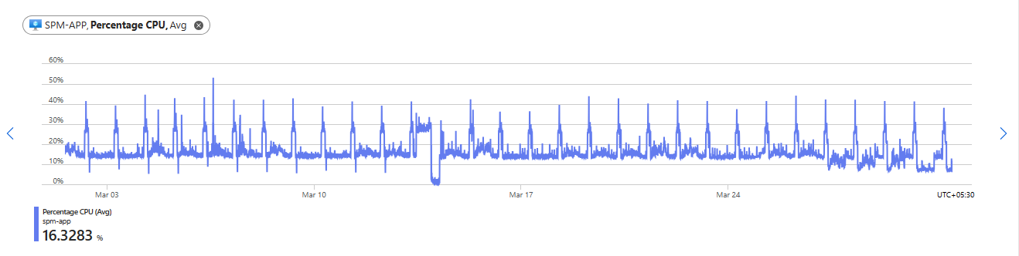

### Memory

Below is the Memory availability graph, it shows that almost 10 GB of memory remains available.

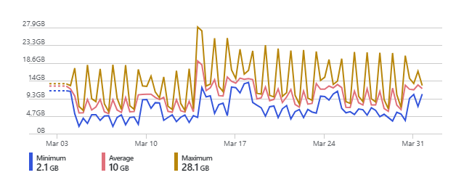

## Database Server

### CPU

The below graph shows the average utilization of CPU over the reporting period, we can see that the monthly average CPU utilization is around only 6% and the max average CPU usage peak also remained below 50% throughout the reporting period.

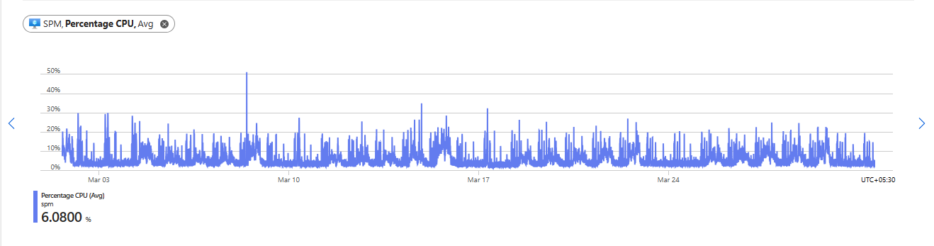

### Memory

Below is the Memory availability graph, it shows that almost 42 GB of memory remains available.

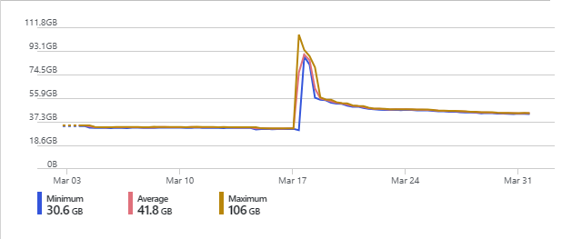

# Service Hours & Uptime

## Approved & Planned Downtime

**01st Mar 2024, Friday: 30 Minutes (20:00 CET)**

This outage was taken for the deployment of Release “23.4.0.0” – Hot Fixes

**05th Mar 2024, Tuesday: 30 Minutes (20:00 CET)**

This outage was taken for the deployment of Release “23.4.0.0” – Hot Fixes

**10th Mar 2024, Sunday: 30 Minutes (20:00 CET)**

This outage was taken for the deployment of Release “23.4.0.0” – Hot Fixes

**15th Mar 2024, Friday: 30 Minutes (20:00 CET)**

This outage was taken for the deployment of Release “23.4.0.0” – Hot Fixes

**21st Mar 2024, Thursday: 30 Minutes (20:00 CET)**

This outage was taken for the deployment of Release “23.4.0.0” – Hot Fixes

**28th Mar 2024, Thursday: 30 Minutes (20:00 CET)**

This outage was taken for the deployment of Release “23.4.0.0” – Hot Fixes

## UNPlanned Downtime

There is no unplanned downtime for an update of servers done in March month.

## Calculated Service Time

Period: 1st of Mar until 31st of Mar.

Total Guarantee uptime is 99,6% as per the various SLAs.

During March the summary of **unplanned** downtime was 0,00 hours which gives a calculated uptime of ((31 days * 24) – 0,00 / (31 days * 24 hours) = **100%,** and therefore have maintained service uptime in line with the respective SLAs.

# Planned Downtime for Next Month Updates (TENTATIVE dates and time)

There are no planned updates scheduled as of now.

# Support Status Overview

|  |  |  |  |  |  |
| --- | --- | --- | --- | --- | --- |
| **Request Type** | **Total** | **Closed** | **Open** | | **On Hold** |
| **Open** | **At Customer End** |
| Incident | 13 | 10 | 0 | 3 | 0 |
| Feature Request | 0 | 0 | 0 | 0 | 0 |
| None | 2 | 1 | 0 | 1 | 0 |
| Question | 1 | 1 | 0 | 0 | 0 |
| Service Request | 4 | 3 | 1 | 0 | 0 |
| Service Task | 0 | 0 | 0 | 0 | 0 |
|  | | | | | |
| **Total** | 20 | 15 | 1 | 4 | 0 |
|  |

No major issues have been discovered that would require follow-up action.